$$Machine Learning$$

$Supervised learning$

$$We have target column or we have labeled data$$

$Regression: Traget data in the form numerical$

$$Linear regression$$

$$Lasso and Ridge regression ( Regularization)$$

$classification:Target data in the form of categorical$

$Logistic regression$

$Decision Tree$

$Naive Bayes$

$KNN$

$Support Vector Machines$

$Ensemble methods$

$Bagging : Random forest$

$Boosting: Adboost Gradient Boost$

$Unsupervised learning$

$Hierarchical Cluster$

$K-means$

$DBscan$

$Rienforcement learning \left( AI\right)$

$$Step-1:Read the data$$

$$Step-2:Perform the EDA ( Preprocess of data)$$

$$Step-3:Develop the model$$

$$Step-4:Evaluation of the model ( Test the performance)$$

$$Step-5:Tuning the model to incresae the performance$$

$$Step-6:Deploy the Model$$

$$Linear Regression$$

$$Understand about Line equations$$

$$y=mx+c$$

$$where m=slope c=intercept$$

$$need to understand the importance of m and c$$

|  |  |  |  |
| --- | --- | --- | --- |
| $$x$$ | $$y=x$$ | $$y=2x$$ | $$y=3x$$ |
| $$0$$ | 0 | 0 | 0 |
| 1 | 1 | 2 | 3 |
| 2 | 2 | 4 | 6 |
| 3 | 3 | 6 | 9 |
| 4 | 4 | 8 | 12 |

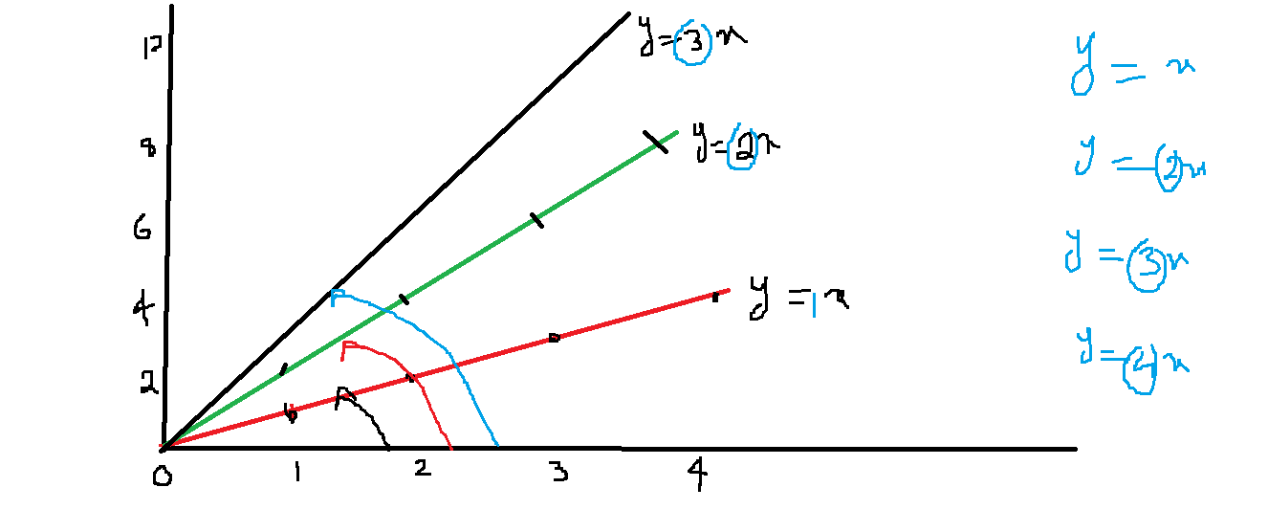

$$The rotation of line depends on slope value \left(m\right)$$

$$As slope value changes the line rotation also change$$

$$Slope=m=\frac{dy}{dx}$$

$$dy=\left(y_{2}-y_{1}\right) [ Difference in two points]$$

$$dx=\left(x_{2}-x_{1}\right) [ Difference in two points]$$

$$\frac{dy}{dx}=\frac{y_{2}-y_{1}}{x_{2}-x_{1}}=The rate of change in y, w.r.t Rate of change in x$$

$$when x changes is y changes or not :$$

$yes , the slope is there$

$No , there is no slope$

$$Slope=m=\frac{dy}{dx}=tanθ$$

$$we can find the Slope by using values: m=\frac{dy}{dx}=\frac{y_{2}-y_{1}}{x_{2}-x_{1}}=$$

$$we can find the Slope by using angle :m=tanθ$$

$$tan0=0 θ=0 === > when you change x , y is not changing$$

$$tan45=1 θ=45=== >when you change x, y also change in equal amount$$

$$tan90=inf θ=90=== >y is changing and x is constant$$

$$Assume that y=x^{2} it is a parabola equation$$

|  |  |  |
| --- | --- | --- |
| x | Y=x^2 |  |
| -2 | 4 | (-2,4) |
| -1 | 1 | (-1,1) |
| 0 | 0 | (0,0) |
| 1 | 1 | (1,1) |
| 2 | 4 | (2,4) |

|  |  |  |  |
| --- | --- | --- | --- |
|  |  |  |  |
|  | 0 | 1 | 2 |
| 1 | 1 | 2 | 3 |
| 2 | 2 | 3 | 4 |
| 3 | 3 | 4 | 5 |
| 4 | 4 | 5 | 6 |

(y=x+1 starting point (0,1)

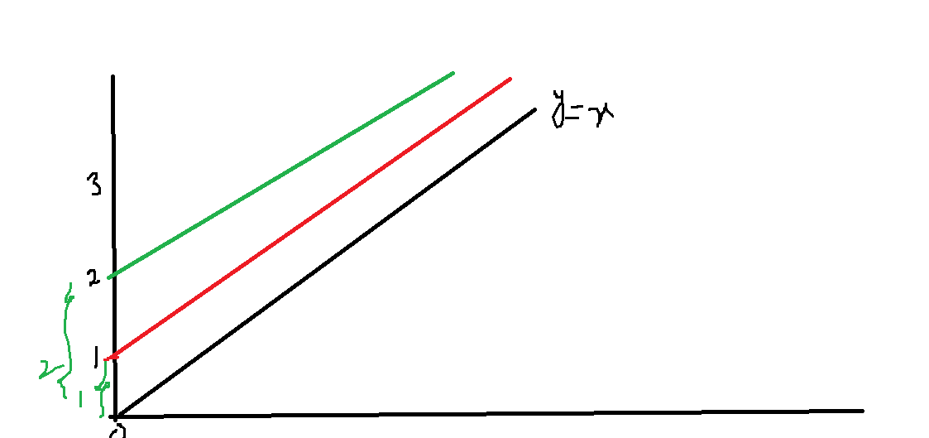

$$Intercept term:C is reponcsible for lift the line$$

$$Slop is m is reponcsible for rotation the line$$